
MAHARASHTRA STATE BOARD OF TECHNICAL EDUCATION
(MUMBAI)
A
Project Report

On
“Bus Tracking”
Submitted by
Dinesh Sitar Koti (508384)
Raj Balu Bhoye (508385)
Vipul Bhagvan Bhurkud (508404)

Guided by:



DEPARTMENT OF COMPUTER ENGINEERING
SHATABDI INSTITUTE OF TECHNOLOGY, AGASKHIND, NASHIK.
(2025-2026)

DEPARTMENT OF COMPUTER ENGINEERING
SHATABDI INSTITUTE OF TECHNOLOGY, AGASKHIND, NASHIK.
(2025-26)
CERTIFICATE
Certified that the project report entitled “Bus Tracking” has been successfully completed by:
Dinesh Sitar Koti (508384)
Raj Balu Bhoye (508385)
Vipul Bhagvan Bhurkud (508404)
As partial fulfillment of Diploma course in Computer Engineering under the Maharashtra State Board of Technical Education, Mumbai during the academic year 2025-2026.
The said work has been assessed by us and we are satisfied that the same is up to the standard envisaged for the level of the course. And that the said work may be presented to the external examiner.

Miss.V.N.Lawand Prof.Megha.V.Warungase
Project GUIDE H.O.D. Computer Dept.
Dr.Sanjay.J.Bagul
External Examiner PRINCIPAL
ABSTRACT

Student safety is a primary concern in our society. Increased rates of student abduction signify the relevance of a proper mechanism to track children. The current system involves students calling the bus driver to ensure to know the current location. There is always an element of uncertainty regarding student whereabouts. Proposed system involves a low-cost solution by allowing students to track bus location via a mobile application. The system involves providing the bus conductor app to update the current stop location, so students are aware of the bus location. This work involves identification of students present in the bus along with tracking of bus.

Keywords: Bus Track, Alert, Android, API’s

ACKNOWLEDGEMENT

With a deep sense of gratitude, we would like to thanks all the people who have lit our path with their kind guidance. We are very grateful to these intellectuals who did their best to help during our project work.
It is our proud privilege to express a deep sense of gratitude to, Prof.Sanjay J. Bagul Principal of Shatabdi Institute of Technology, Agaskhind, Nasik, for his comments and kind permission to complete this project.
I acknowledge and special thanks to encouragement, and austerity of our Miss.V.N.Lawand whose guidance did half the magic of keeping me thrilled throughout this project.
We remain indebted to Prof. Megha V. Warungase, H.O.D, of Computer Engineering Department For their timely suggestion and valuable guidance.
The special gratitude goes to Teaching staff members, and Non-Teaching staff members, of Computer Department for his expensive, excellent and precious guidance in completion of this work. We thanks to all the colleagues for their appreciable help for our working project.
With various industry owners or lab technicians to help, it has been our endeavor to throughout our work to cover the entire project work.
We also thankful to our parents who providing their wishful support for our project completion successfully.
And lastly, we thanks to our all friends and the people who are directly or indirectly related to our project work.

Dinesh Sitar Koti
Raj Balu Bhoye
Vipul Bhagvan Bhurkud

CONTENTS
Sr.No. | Name of topic | Page no.
1 | Abstract | iv
2 | Acknowledgement | v
3 | List of Content | vi
4 | Introduction | 1
5 | Literature Survey
6 | Proposed System
7 | Requirements
8 | Project Design and Code
9 | Software Requirement Specification
10 | Software Implementation
12 | Technical Specifications
13 | Software Testing
14 | Advantages
15 | Output
16 | Conclusion
17 | References

List of the figures:
Figure. No. | Name of figure | Page no.
3.1 | Proposed System
5.1 | System Architecture
5.2 | DFD Level
5.3 | DFD Level 1
5.4.1 | Activity Diagram
5.4.2 | Class Diagram
5.4.3 | Sequence Diagram
5.4.4 | Use Case Diagram
7.2 | System Flow Diagram
9.1 | Black Box Testing
9.2 | White Box Testing
7.5
7.6
7.7
7.8
8.1
8.2
10.1

List of the Tables:
Table No. | Title of Table | Page no.
9.3
2.2.2
4.1
4.2

Chapter 1
Introduction

The general objective of the development of this system is to help people track things in more efficient way and effective way resulting in greater reliability. In real life, when a freight service provider wants to track his/ her shipment service which is been carried by a vehicle. It’s really difficult to man- age all those fleet of vehicles which is in movement in whereas corners of the city. There are buses made available for passengers travelling distances, but not many passengers have complete information about these buses. Complete information namely the number of buses that go to the required destination, bus numbers, bus timings, the routes through which the bus would pass, time taken for the bus to reach, maps that would guide the passenger with his/her route and most importantly, track the current location of the bus and give the correct time for the bus to reach its bus stop. The proposed system deals with overcoming the problems stated above. The system is an Android application that gives necessary information about all the buses travelling in Pune. This information overcomes the problems faced in the previously built application “Pune Bus Guide”. The platform chosen for this kind of system is android, reason being Android Operating System has come up on a very large scale and is owned by almost every second person. Also, Android is a user friendly platform, thereby enabling ease of access for all the users. A number of applications made for the Android Operating System is increasing on a large scale ever since its advent. Android is an open source mobile software environment. Brought up by Google, the operating system has been made Linux based and uses Java programming language. It has a virtual machine that is used to optimize memory usage as well as resources. This application has been developed using IDE (Android Studio 1.6) with ADT (Android Development Tools) and Android SDK (Software Development Kit). There are a number of constraints that need to be satisfied.

1.1 Motivation

In today's fast-paced world, ensuring the safety and security of students during their daily commute is of utmost importance. The rising incidents of child abduction and the general concern of parents and schools regarding student safety have highlighted the need for a more reliable and transparent system. Traditional methods of manually contacting the bus driver to inquire about the bus’s location are not only inefficient but also prone to communication gaps and delays. This lack of real-time information can lead to unnecessary anxiety among parents and students.
To address these challenges, there is a strong need for a smart, cost-effective, and user-friendly solution that can provide live updates about the bus location and student presence. Leveraging mobile technology to develop a tracking system empowers students, parents, and school authorities with accurate and timely information. This not only enhances safety but also brings peace of mind and fosters trust in the school transport system. The motivation behind this project is to bridge the communication gap and create a secure and transparent environment for student transportation through technological innovation.

1.2 Problem Definition
The problem at hand revolves around the necessity for an effective Bus Location Tracking and Alert System tailored specifically for students. In the current scenario, challenges such as the inability to monitor the real-time location of school buses, safety concerns during transit, and a communication gap between schools, parents, and students have become prominent issues. This lack of a centralized system for bus tracking contributes to uncertainties, operational inefficiencies, and safety anxieties. Additionally, emergency situations may not be promptly addressed due to the absence of a reliable alert system. To address these challenges, the proposed solution entails the development and implementation of a comprehensive system that ensures real-time bus location tracking, timely communication of updates, and swift alerts during emergencies. This solution not only aims to enhance the safety and security of students but also contributes to operational efficiency, parental assurance, and regulatory compliance in school transportation.

1.3 Objectives

To enhance student safety by implementing a real-time tracking system for school buses using a mobile application.
To reduce uncertainty and improve communication between students, parents, and school authorities regarding bus location and student presence.
To develop a low-cost and efficient mobile application that allows students to view the current location of their school bus.
To provide a mobile interface for bus conductors to update the current stop and student boarding status in real-time.
To enable identification of students present in the bus, ensuring accurate attendance and safety monitoring during transportation.
To improve the overall management of student transportation by integrating modern technology into the existing system.

Chapter 2
Literature Survey

Title: Application-Based Bus Tracking System
Authors: Shubham Jain, Adarsh Trivedi, Shweta Sharma
Published by: IEEE (Institute of Electrical and Electronics Engineers)
Citation Information:
Number of Citations in Other Papers: 6
Full Text Views: 281
Abstract: The paper titled "Application-Based Bus Tracking System" authored by Shubham Jain, Adarsh Trivedi, and Shweta Sharma presents a comprehensive exploration of a bus tracking system based on applications. Published in the IEEE domain, the paper delves into the application-driven approach to tracking buses, offering valuable insights into the implementation and functionality of such a system. With 6 citations in other research papers and 281 full text views, the paper indicates its impact and relevance in the field.
  - Existing Systems:

Existing bus tracking systems often incorporate GPS technology to enable real-time monitoring of the location of school buses. These systems may include mobile applications or web interfaces that allow parents, school administrators, and transportation staff to track the buses' movements. Additionally, some systems provide notifications or alerts to inform parents and students about the bus's estimated arrival time, delays, or other relevant information.

Key features of existing systems may include:

Real-time GPS Tracking: Utilizing GPS technology to provide accurate and up-to-date information on the current location of school buses.

Mobile Applications: User-friendly mobile apps for parents and students to easily access information about bus locations, routes, and any updates.

Communication Tools: Integration of communication tools to send alerts, notifications, or messages to parents, students, and school staff in case of emergencies, delays, or route changes.

Geofencing: Setting up virtual geographical boundaries (geofences) to trigger alerts when a bus enters or exits specific areas.

Data Analytics: Analysis of transportation data to optimize bus routes, reduce fuel consumption, and improve overall operational efficiency.

Safety Features: Implementation of safety features such as emergency alerts, panic buttons, or video surveillance to ensure the well-being of students during transit.

Integration with School Management Systems: Seamless integration with school management systems for better coordination and information sharing.

Drawback of Existing Systems:
Accuracy Issues: Existing systems may sometimes face challenges in providing accurate real-time tracking due to issues such as signal interference, poor GPS reception in certain areas, or technical malfunctions.
Limited Integration: Lack of seamless integration with other school management systems may hinder the overall efficiency of the transportation process. Siloed systems may lead to data discrepancies and difficulties in information sharing.
Communication Gaps: In some cases, there may be communication gaps between the tracking system and relevant stakeholders, leading to delays or missed notifications regarding changes in bus schedules, delays, or emergencies.
Dependency on Connectivity: The effectiveness of existing systems heavily relies on a stable internet or cellular connection. In areas with poor connectivity, the system may experience disruptions, affecting real-time tracking and communication capabilities.
Cost and Implementation Challenges: The initial costs associated with implementing a comprehensive bus tracking system, including hardware, software, and training, can be a barrier for some educational institutions. On-going maintenance costs and potential technical glitches may also contribute to financial concerns.
Privacy Concerns: Parents and students may express concerns about privacy issues, especially if the tracking system involves extensive data collection. Striking a balance between ensuring safety and addressing privacy concerns is crucial.

Chapter 3
Proposed System

The proposed system is a comprehensive Bus Location Tracking and Alert System specifically designed to address the identified challenges in student transportation. It involves the development of a centralized platform that enables real-time tracking of school buses, providing accurate and up-to-date information on their current locations. This system incorporates a robust communication module to bridge the gap between schools, parents, and students, ensuring timely updates on bus movements, route changes, and any unforeseen circumstances.

Key features of the proposed system include an efficient alert mechanism for emergencies, such as accidents or delays, enabling immediate communication to parents, school staff, and emergency responders. To enhance operational efficiency, the system utilizes data-driven insights to optimize bus routes, reducing fuel consumption, maintenance costs, and overall operational inefficiencies.

Moreover, the proposed system prioritizes safety by offering a transparent tracking system that provides parents with real-time information, offering assurance regarding their child's well-being during transportation. The system also takes into account regulatory compliance, ensuring adherence to relevant standards and regulations governing school transportation.

In summary, the proposed Bus Location Tracking and Alert System aims to provide a comprehensive solution to the identified challenges, fostering a safer, more efficient, and transparent environment for student transportation.

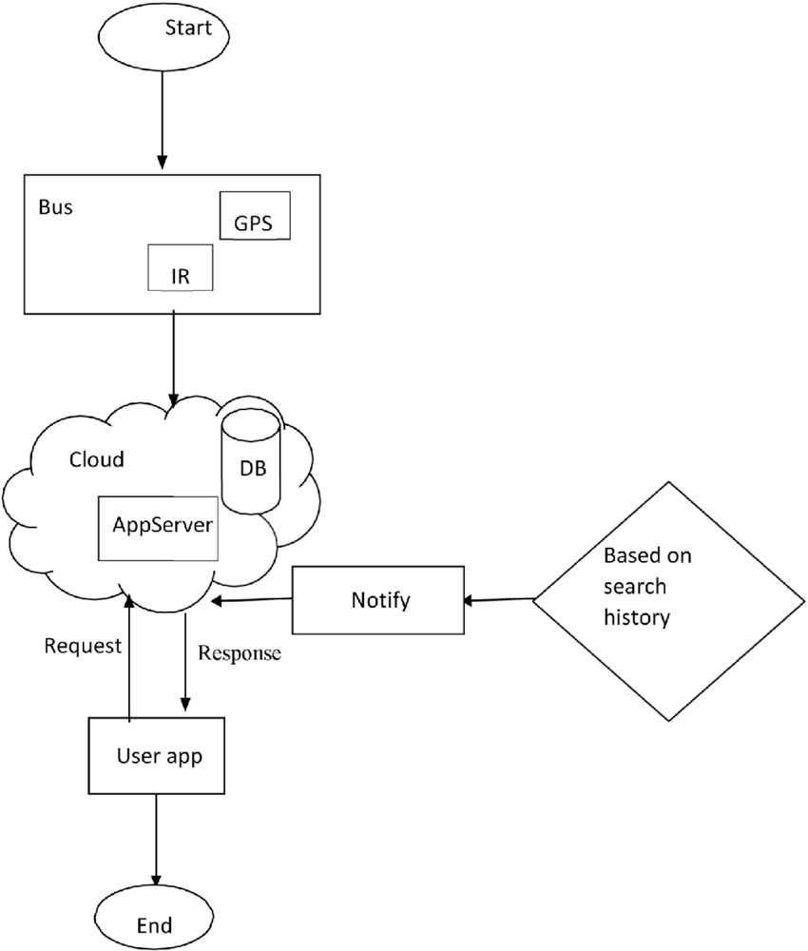
Fig: 3.1 Proposed System

Chapter4
Requirements

Requirement analysis is a crucial phase in the development of any system, including a Bus Location Tracking and Alert System. It involves gathering, documenting, and analyzing the needs and expectations of stakeholders to define the system's specifications. Here's an overview of requirement analysis for a Bus Location Tracking and Alert System:
Stakeholder Identification: Identify key stakeholders, including school administrators, parents, students, and transportation staff. Understand their roles, responsibilities, and expectations regarding the bus tracking system.
Functional Requirements: Define the core functionalities of the system, such as real-time bus tracking, route optimization, communication tools, and emergency alert features. Specify user roles and permissions, ensuring that each stakeholder group has access to relevant information and functionalities.
User Interface (UI) and User Experience (UX) Requirements: Design an intuitive and user-friendly interface for both mobile applications and web platforms. Consider the needs of parents, students, and school staff, ensuring that the interface is easy to navigate, and key information is readily accessible.
Real-Time Tracking and GPS Integration: Specify the requirements for accurate GPS integration to provide real-time tracking of buses. Define the frequency of location updates, ensuring timely and precise information.
Communication Requirements: Determine communication channels and tools for sending alerts, notifications, and updates to parents, students, and school administrators. Define protocols for emergency notifications and communication during unforeseen events.
Integration with Existing Systems: Identify and document any existing systems, such as school management systems, that need to integrate with the bus tracking system. Establish data exchange protocols to ensure seamless integration and consistency of information.

Overall Description

Functional Requirements
Functional requirements describe the specific functionalities and features that a Bus Location Tracking and Alert System must possess to meet the needs of its users. Here are some functional requirements for such a system:

- Real-Time Bus Tracking: The system should provide real-time tracking of school buses using GPS technology. Users, including parents, students, and school administrators, should be able to view the live location of buses on a map.
- Route Optimization: Implement route optimization algorithms to ensure efficient and timely transportation. The system should dynamically adjust routes based on factors such as traffic conditions, road closures, and other relevant data.
- User Roles and Permissions: Define different user roles, such as administrators, parents, and students, each with specific permissions. Ensure that users have access to information and features relevant to their roles.
- Communication Tools: Implement communication tools for sending alerts, notifications, and updates to users. Include features for two-way communication between parents and school administrators for inquiries or emergency situations.
- Emergency Alerts: Provide an emergency alert system that enables quick communication during critical situations. Include panic buttons or quick alert mechanisms for bus drivers to notify authorities in case of emergencies.
- Geofencing: Implement geofencing to define virtual boundaries for specific areas. Send alerts to parents or school administrators when a bus enters or exits predefined zones.
- Data Analytics for Route Optimization: Utilize data analytics to analyze historical transportation data and optimize bus routes. Identify trends and patterns to enhance overall operational efficiency.
- User Authentication and Authorization: Implement secure user authentication to ensure that only authorized individuals can access the system. Define authorization levels for different user roles.

Non-Functional Requirements
Non-functional requirements specify criteria that are not directly related to the system's specific behaviors or features but are essential for ensuring its overall performance, security, and usability. Here are some non-functional requirements for a Bus Location Tracking and Alert System:

- Performance: Response Time: The system should respond to user requests within a specified time limit (e.g., loading maps, fetching bus locations).
- Scalability: The system must be scalable to handle an increasing number of users and buses without a significant degradation in performance.
- Reliability: Availability: The system should be available for use during peak hours and emergency situations.
- Fault Tolerance: Implement measures to ensure system reliability, such as redundancy and failover mechanisms.
- Data Encryption: All communication between users and the system should be encrypted to protect sensitive information.
- User Authentication: Implement secure user authentication mechanisms to prevent unauthorized access.
- Access Controls: Define access controls to restrict users' permissions based on their roles.
- User Capacity: The system should accommodate a scalable number of users, including parents, students, and administrators.
- Bus Capacity: Scale the system to handle an increasing number of buses as the transportation network expands.
- User Interface Design: The user interface should be intuitive, user-friendly, and accessible on various devices (web, mobile).
- Accessibility: Ensure the system is accessible to users with disabilities, following relevant accessibility standards.
- Cross-Browser Compatibility: The system should function consistently across different web browsers.
- Mobile Device Compatibility: Ensure compatibility with various mobile devices and operating systems.
- Backup Frequency: Regularly back up system data to prevent data loss.
- Recovery Time: Define the maximum acceptable time for data recovery in case of system failures.

Software and Hardware Requirement

Hardware Requirement
- Processor: i3 or i5
- RAM: 8 GB or higher
- Storage: SSD/HDD with at least 500 GB storage space
- Network Interface: Gigabit Ethernet

Software Requirements

- Operating System:
- Server: Linux-based OS (Ubuntu Server, CentOS) or Windows Server OS (Windows Server 2016 or later)
- Development Machines: Windows,
- Android Studio
- Web Services

Design Requirements

Design requirements outline the specifications and constraints that guide the development of the Bus Location Tracking and Alert System. They encompass the architectural, user interface, and technical aspects necessary to bring the system to fruition. Below are design requirements for such a system:

- Modularity: Design the system with modular components to facilitate future updates and enhancements.
- Scalability: The architecture should support the addition of new features and accommodate an increasing number of users and buses.
- Intuitive Interface: Design a user-friendly interface for both web and mobile applications.
- Consistency: Ensure consistency in design elements, layout, and navigation across different sections of the application.
- Responsive Design: Implement responsive design principles to provide a seamless experience on various devices and screen sizes.
- Map Integration: Utilize interactive maps for displaying real-time bus locations and route information.
- Customization: Allow users to customize map views, such as zoom levels and map layers.
- Notification Styles: Design clear and concise notification styles for alerts, updates, and emergency messages.
- Two-Way Communication: Implement an intuitive two-way communication interface for users to interact with the system.
- Panic Button Design: Design a prominent and easily accessible panic button for bus drivers in case of emergencies.
- Emergency Alert Interface: Create a distinct interface for emergency alerts to grab immediate attention.
- Data Visualization: Use charts and graphs for presenting analytics and performance metrics.

Applications
Driver Behavior Monitoring: Tracking systems can monitor driver behavior, ensuring that drivers adhere to speed limits and drive safely, thereby increasing the safety of the students.
Attendance Tracking: Schools can automate attendance tracking, ensuring that no student is left behind, and accurate records are maintained

Chapter 5
Project Design and Code

System Architecture

Authorized person can track the location of the bus and estimate the arrival time of the bus. It is also provided with the nearest stoppage from the current location. Therefore, passengers with no worry can utilize their waiting time by choosing the nearest route.
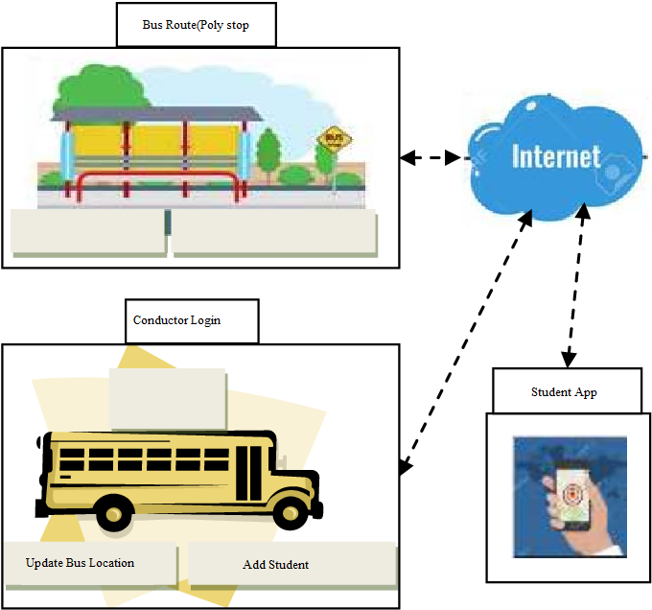
Fig 5.1 : Block Diagram of Bus location tracking & alert to students

Android App For Mobile User Modules
1.Conductor
2. Student:
This module is designed for the bus driver. The authorized bus drivers can use this module by providing their unique login credentials. They need to start their location services before driving. The current location of the bus will automatically be updated from the driver’s mobile to the server every moment. Admin Module: This module is designed for the bus administrator for updating the information. Admin can log in to the admin account after authentication and authorization. He can add the driver, buses and students. Student Module: This is the most important module and the soul of the system. Users of this module need to click on the student login. They can access the details of all the buses through their smartphones. Here, they will get all the buses information. Students can track the location of their buses from any location. A student must make sure that their location service is active. SNAPSHOTS Login page

DFD Level

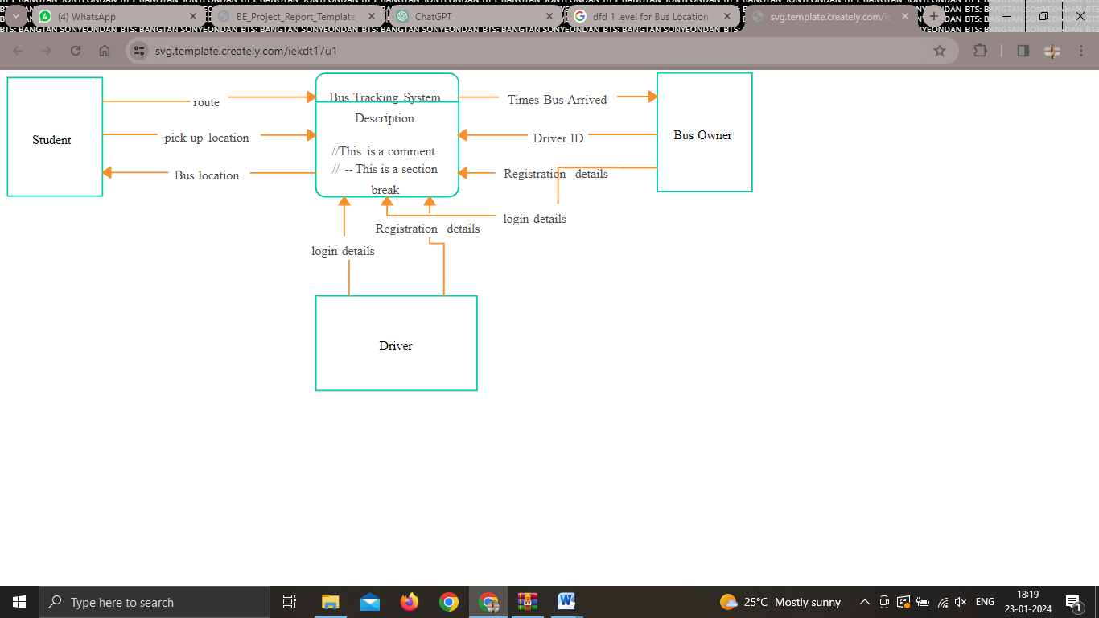Fig:5.2 DFD Level

A Data Flow Diagram (DFD) is a graphical representation illustrating the flow of data within a system. The hierarchical structure of DFDs consists of different levels, starting with a high-level overview in the Level 0 DFD, also known as the Context Diagram. At this level, the entire system is depicted as a single process, interacting with external entities through data flows. The Level 1 DFD breaks down this single process into subprocesses, providing a more detailed view of data flow within specific parts of the system. Further decomposition into Level 2 DFDs or additional levels offers even greater granularity, allowing a thorough understanding of processes, data stores, data flows, and external entities. Processes, represented by rectangles, signify activities or transformations, while data stores (parallel lines) indicate where data is stored.

DFD Level 1

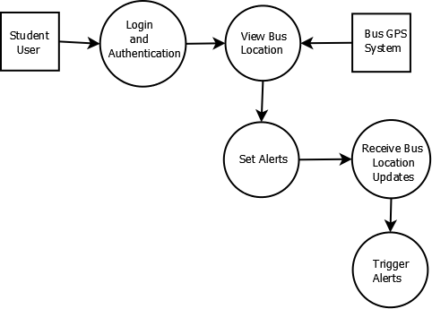

Fig:5.3 DFD Level 1

A Level 1 Data Flow Diagram (DFD) is a refined representation that delves deeper into the intricacies of a system compared to its Level 0 counterpart. In the Level 1 DFD, the primary process identified in the Level 0 diagram is decomposed into sub-processes, each offering a more detailed view of specific functionalities within the overall system architecture. This decomposition allows for a more nuanced understanding of the processes and interactions involved.
For instance, consider a "Main Process" from the Level 0 DFD, which is further elaborated in the Level 1 DFD as "Subprocess 1." This subprocess represents a more specific and detailed aspect of the overarching system functionality. The Level 1 DFD illustrates the flow of data, showing how information is exchanged between "Subprocess 1" and an external entity, such as

UML

Activity Diagram
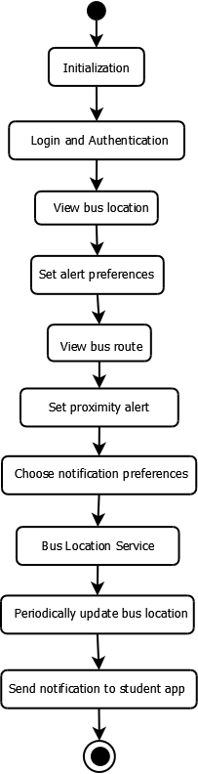
Fig:5.4.1 Activity Diagram

An Activity Diagram is a visual representation that illustrates the flow of activities within a system, often used in the context of business process modeling or software engineering. At its core, this diagram provides a dynamic view of the system's behavior, emphasizing the sequence and dependencies of various activities.
In an Activity Diagram, activities are represented by rounded rectangles, and arrows indicate the flow of control between them. Decision points, represented by diamonds, guide the flow based on conditions or decisions within the system. Swimlane may also be employed to depict different entities or roles responsible for specific activities, enhancing the clarity of responsibility assignment.
For example, in a business process, the diagram could outline the sequential steps involved in handling a customer order, from order initiation to fulfillment. Decision points might delineate different paths based on product availability or customer preferences. Overall, the Activity Diagram serves as a valuable tool for stakeholders to comprehend the operational dynamics of a system, aiding in the identification of potential improvements or optimizations.

Class Diagram

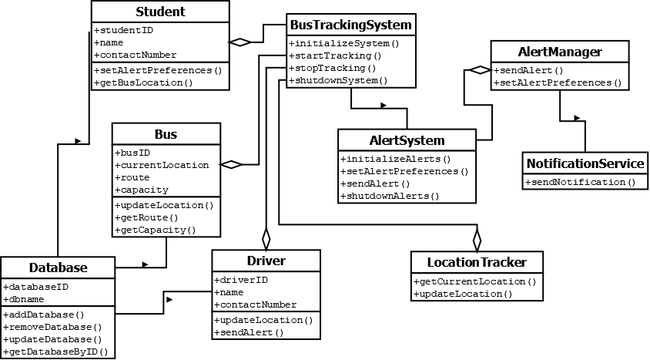Fig: 5.4.2 Class Diagram

A Class Diagram is a fundamental component of Unified Modeling Language (UML) used in software engineering to visually represent the structure and relationships within a system. It provides a static view, emphasizing the classes, attributes, methods, and associations that make up the building blocks of an object-oriented system.
In the Class Diagram, classes are represented as rectangles, detailing the attributes and methods associated with each class. Lines and arrows between classes indicate relationships, such as associations, aggregations, or inheritances. Class Diagrams help stakeholders, including developers and system architects , understand the organization of classes and the interactions between them.

Sequence Diagram

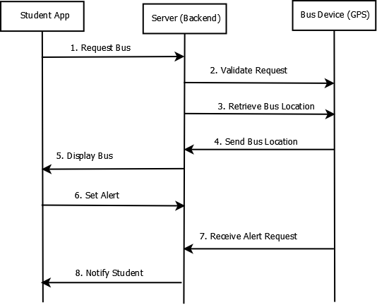
Fig:5.4.3 Sequence Diagram:

A Sequence Diagram is a visual representation used in Unified Modeling Language (UML) to illustrate the interactions and order of messages exchanged between objects or components within a system. It provides a dynamic view of a scenario, emphasizing the sequence of events that occur during the execution of a particular use case or operation.
In a Sequence Diagram, participants (objects or actors) are depicted as vertical lifelines, and messages between them are represented by horizontal arrows. The vertical axis represents time, progressing from top to bottom. The diagram effectively captures the chronological flow of activities and the communication patterns between different elements of a system.

Use Case Diagram

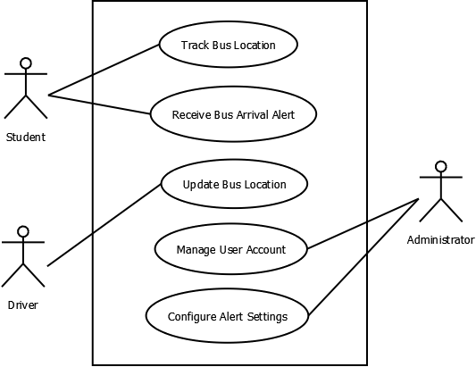Fig:5.4.4 Use Case Diagram

A Use Case Diagram is a visual representation in Unified Modeling Language (UML) that illustrates the interactions between various actors and the system under consideration. It is particularly useful for capturing the high-level functionalities or features of a system and how different users (actors) interact with it.
In a Use Case Diagram, actors are represented as stick figures, and use cases are depicted as ovals. Lines connecting actors to use cases indicate the association between users and the functionalities they engage with. The diagram provides a top-level view of the system's functionalities without delving into the details of internal processes.

Chapter 6

Software Requirement Specification

Software Requirement Specification (SRS)

Introduction
      - Purpose: The main purpose for preparing this document is to give a general insight into the analysis and requirements of the system or situation and for determining the operating characteristics of the system.
      - Scope: The scope of the system is help to avoid traffic congestion, avoid unnecessary delay and make reach child in time

Overall Description

Functional Requirements
Functional user requirements may be high-level statements of what the sys- tem should do but functional system requirements should also describe clearly about the system services in detail. The following are the key fields, which should be part of the functional requirements:
      - User: Execute the task
      - Usability: This relates to how easily people can use your app. A measure of usability could be the time it takes for end users to become familiar with your app’s functions, without training or help.
      - Reliability: This is the percentage of time that your app works correctly to deliver the desired results, despite potential failures in its environment.
      - Performance: This is essentially how fast your app works. A performance requirement for the app could be start in less than 20 seconds.
      - Responsiveness: This requirement ensures that your app is ready to respond to a user’s input or an external event no matter what it’s doing currently

Non-Functional Requirements
      - Execution Qualities usability which is observable during operation(at run-time).
      - Evolution qualities such as maintainability, extensibility and scalability, which are embodied in the static structure of the system.

Minimum Software Requirements
Platform:

- Operating System :- Windows 11 Or MAC OS
- Java :- Java SE 8 with minimum update (8u51)
- Android Studio :- Latest Android Studio(Electric Eel)

Chapter 7

Software Implementation

Proposed Work

- Requirement Analysis: Initiate comprehensive discussions with stakeholders to gather requirements and understand the intricacies of access control needs across various sectors. Document user stories, use cases, and functional requirements to serve as the foundation for system design and development.
- System Design: Architect the system with a focus on scalability, security, and user experience. Design the user interface to be intuitive and accessible, ensuring seamless interaction for both administrators and end-users. Define the data schema and establish protocols for encryption and secure transmission of QR codes.
- Implementation: Develop the QR-based pass system according to the defined architecture and design. Implement robust security measures to safeguard against tampering and unauthorized access. Integrate with existing infrastructure and external systems to ensure interoperability.
- Testing: Conduct rigorous testing to validate the functionality, performance, and security of the system. Perform unit testing, integration testing, and system testing to identify and rectify any defects or vulnerabilities. Collaborate with stakeholders to conduct user acceptance testing (UAT) and refine the system based on feedback.
- Deployment: Prepare the system for deployment in production environments, ensuring compatibility with existing hardware and software infrastructure. Develop deployment scripts and procedures to streamline the deployment process. Monitor system performance during deployment and address any issues that may arise.

Module

- Admin Module: The QR-based pass system comprises two essential modules: the admin module and the service module, each serving distinct roles in its operation. Firstly, the admin module stands as the backbone of system administration, catering primarily to privileged users such as administrators or system managers. This module empowers administrators to configure system settings, manage user accounts, oversee data integrity, generate reports, and perform routine maintenance tasks. Administrators play a critical role in ensuring that the system operates efficiently, securely, and in alignment with organizational requirements. They facilitate smooth system operation through user management, configuration adjustments, and proactive maintenance, thereby laying the groundwork for a robust and reliable QR-based pass system.
- Service Module: the service module serves as the front-facing interface for end-users interacting directly with the QR-based pass system. Designed to deliver core functionalities and services to users, this module facilitates the generation, validation, and utilization of QR codes for access. It empowers users with seamless access control mechanisms, timely notifications, and insightful analytics. Through QR code generation, access control validation, communication, and integration with external systems, the service module ensures a user-friendly experience, enhancing convenience, security, and efficiency. Together, the admin module and service module synergize to provide a comprehensive and user-centric solution for access control, catering to the diverse needs of both administrators and end-users within various industries and settings.

Fig: 7.2 System Flow

Chapter 8

Technical Specification

Technologies Used

Frontend Technologies :
• HTML5, CSS3, JavaScript
• Framework: Bootstrap / Tailwind
• Charts & Reports: Chart.js or similar

Backend Technologies :
• Programming Language: PHP / Node.js / Python
• Framework: CodeIgniter (for PHP) or Express.js (for Node.js)
• API: RESTful APIs for communication between app, hardware, and backend
• Database: MySQL / PostgreSQL
• Notification Service: Firebase Cloud Messaging (FCM)

Chapter 9

Software Testing

Black Box Testing

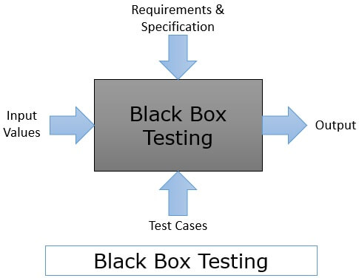
Fig 9.1 : Black Box Testing
- External Perspective:
Testers approach the system solely from an external perspective, treating it as a closed box with inputs and outputs.
- External Perspective:
Testers approach the system solely from an external perspective, treating it as a closed box with inputs and outputs.
- No Knowledge of Internal Code:
Testers do not have access to the source code, architecture, or internal structures of the software being tested.
- Test Cases Based on Specifications:
Test cases are designed based on the software's specifications, requirements, and functional specifications. This ensures that the testing is aligned with the intended behavior of the software.
- Functional and Non-functional Testing:
Black box testing covers both functional aspects (valid inputs, expected outputs) and non-functional aspects (performance, usability, security) of the software.
- System Independence:
Black box testing is independent of the system's underlying technology, implementation, or programming language. Testers focus on testing the system's behavior as it is presented to users.
- Types of Black Box Testing:
Different types of black box testing include functional testing, non-functional testing, regression testing, acceptance testing, and more.

Advantages

Black box testing allows for testing from an end-user perspective, identifying discrepancies between expected and actual outcomes. It helps ensure that the software meets specified requirements and is not influenced by the tester's biases or knowledge of the internal code.

Disadvantages

The testing coverage may be limited as the internal logic is not considered. Certain code paths or scenarios may be overlooked. Additionally, since testers don't have knowledge of the internal code, it might be challenging to identify certain types of issues, such as memory leaks or performance bottlenecks.

White Box Testing

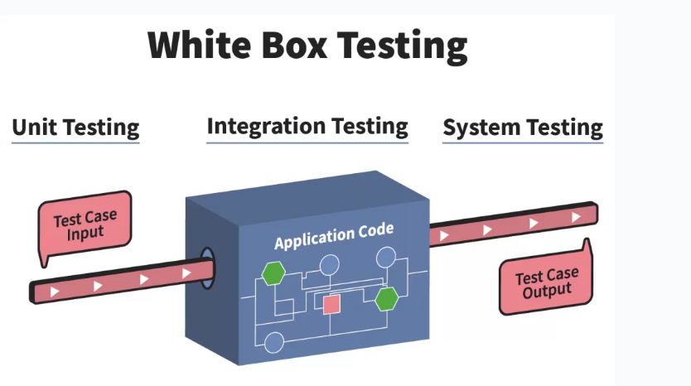
Fig 9.2 : White Box Testing
White box testing, also known as clear box testing or glass box testing, is a software testing approach that examines the internal structure, logic, and code of a software application. The primary goal of white box testing is to ensure that all internal components and code paths are tested thoroughly, with the aim of identifying and fixing errors, ensuring code quality, and validating the correctness of the implemented algorithms. Unlike black box testing, which focuses on the functional aspects without knowledge of the internal code, white box testing requires a deep understanding of the application's architecture and source code.
- Knowledge of Internal Code:
Testers need access to the source code of the software being tested. This enables them to understand the internal structures, algorithms, and decision-making processes within the application.
- Code Coverage:
White box testing aims to achieve high code coverage by executing various code paths, including different branches, conditions, and statements. Code coverage metrics are used to measure the extent to which the code has been exercised during testing.
- Testing Levels:
White box testing can be applied at different levels of the software development life cycle, including unit testing (testing individual functions or modules), integration testing (testing interactions between components), system testing (testing the entire system), and regression testing (ensuring that changes do not introduce new issues).
- Testing Techniques:
Various testing techniques are used in white box testing, including statement coverage, branch coverage, path coverage, and condition coverage. These techniques help ensure that all aspects of the code are thoroughly tested.
- Static and Dynamic Testing:
Static testing involves analyzing the code without executing it. Techniques such as code reviews, inspections, and walkthroughs fall under static testing. Dynamic testing involves running the code and observing its behavior during execution.

Advantages

- Thorough coverage of the internal code.
- Early detection of code-related issues.
- Improved code quality.
- Efficient identification of security vulnerabilities.
- Integration with the development process, facilitating continuous improvement.

Disadvantages

- Requires a deep understanding of the internal code.
- May not be as effective in uncovering issues related to the software's external behavior.
- Dependency on skilled testers with programming expertise.

Chapter 10

Advantages

- Real-time Tracking: Parents and school authorities can track the exact location of the school bus in real-time, ensuring that students are on the right route and safe throughout the journey.
- Emergency Response: In case of emergencies or unexpected delays, parents and school officials can quickly locate the bus and respond appropriately.
- Geofencing: Geofencing technology can alert parents and school staff if the bus deviates from its planned route, ensuring that students are not taken to unauthorized locations.
- Route Optimization: Schools can optimize bus routes based on real-time traffic data, ensuring that buses take the most efficient routes and reach destinations on time.
- Alerts for Delays: Parents can receive alerts if the bus is running late, allowing them to plan accordingly and reducing wait times at bus stops.

Chapter 11

Output

Chapter 12

Conclusion

Conclusion

In this project we designed and developed a real time bus tracking system using Android studio. In this project we try to save the time of the students mainly who uses the college transportation service and we also tend to help them with easy and tension mornings for a bright and peaceful day. This application does not need any external hardware except a smartphone which is available to all the students. So, the overall cost is very low or no cost needed for tracking the bus location. It provides nearly accurate data in real time that makes possible for the user to track the buses.

Future Work

The future scope of a Bus Location Tracking and Alert System holds promising opportunities for enhancement and expansion. As technology evolves, there are several areas where the system could be further developed and improved:

Integration with Emerging Technologies: Explore integration with emerging technologies such as Internet of Things (IoT), artificial intelligence, and machine learning to enhance the system's capabilities. Implementing IoT sensors on buses or utilizing AI algorithms for predictive analysis could lead to more efficient route planning and improved operational insights.
Enhanced User Experience: Continuously focus on improving the user interface and experience to make the system more intuitive and user-friendly. Incorporate features such as augmented reality for a more interactive and engaging experience, especially for students and parents.
Mobile App Innovations: Explore innovative features for mobile applications, such as real-time chat support, gamification elements for student engagement, and personalized notifications based on user preferences. Consider leveraging mobile app advancements, such as augmented reality for visualizing bus routes or integrating with virtual assistants for voice-based interactions.
Predictive Maintenance: Introduce predictive maintenance features to anticipate and address potential issues with the buses before they occur. Utilize data analytics and machine learning algorithms to analyze historical maintenance data and predict when specific components may require attention.
Advanced Security Measures: Implement advanced security measures, including biometric authentication for bus drivers, to ensure the safety and security of students. Explore blockchain technology for enhancing data security and ensuring the integrity of the information within the system

Chapter 13

References

[1] Yuji Mizuno; Teppei Baba; Yoshito Tanaka; Fujio Kurokawa; Masaharu Tanaka; Ilhami Colak; Nobumasa Matsu “A New Load Prediction Method and Management of Distributed Power System in Island Mode of a Large Hospital”/2018
[2] B. Hu and M. Ester, “Social topic modeling for point-of-interest recommendation in location-based social networks,” in 2014 IEEE International Conference on Data Mining (ICDM), pp. 845–850, IEEE, 2014.
[3] Mohammad Reza Khoie, Tannaz Sattari Tabrizi,Elham Sahebkar Khorasani, Shahram Rahimi and Nina Marhamati “A Hospital Recommendation System Based on Patient Satisfaction Survey/2017”
[4] E. Velasco, T. Agheneza, K. Denecke, G. Kirchner, and T. Eckmanns, “Social media and internet-based data in global systems for public health surveillance: a systematic review,” Milbank Quarterly, vol. 92, no. 1, pp. 7–33, 2014.
[5] Z. Yao, Y. Fu, B. Liu, Y. Liu, and H. Xiong, “Poi recommendation: A temporal matching between poi popularity and user regularity,” in 2016 IEEE 16th International Conference on Data Mining (ICDM), pp. 549– 558, IEEE, 2016
[6] Min Chen, Yixue Hao, Kai Hwang, Lu Wang. “Disease prediction by Machine Learning over big data from Healthcare Communities” IEEE-2015
[7] Bo Hu and Martin Ester “Social topic modelling for point of interest recommendation in location based social networks”/2014 IEEE
[8] Yuji Mizuno; Teppei Baba; Yoshito Tanaka; Fujio Kurokawa; Masaharu Tanaka; Ilhami Colak; Nobumasa Matsu “A New Load Prediction Method and Management of Distributed Power System in Island Mode of a Large Hospital”/2018
[9] B. Hu and M. Ester, “Social topic modeling for point-of-interest recommendation in location-based social networks,” in 2014 IEEE International Conference on Data Mining (ICDM), pp. 845–850, IEEE, 2014.

